Project List for Adv. Printmaking 2

Make your own Wrapping Paper- Fall Final Mrs. Riley: Adv. Printmaking 2

Overview:
Last year you created your own Greeting card series. This year you will create your own wrapping paper. We will get you a roll of paper and you will print the whole thing! The theme of the paper is up to you (holiday, birthday, wedding, etc). Create a design that is large and able to be repeated well. This can be a relief print either lino, or a stamp made from various materials or it can be a stencil.

Requirements:
- 25 pts. Good craftsmanship- paper is kept clean, no fingerprints, not wrinkled, etc.
- 25pts. Successful prints- prints are checked before plate or stencil is pulled to guarantee good prints each time.
- 25pts. Design is repeated cleanly and lined up well.
- 25pts. Full roll of paper is printed on.

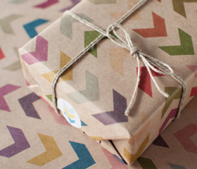

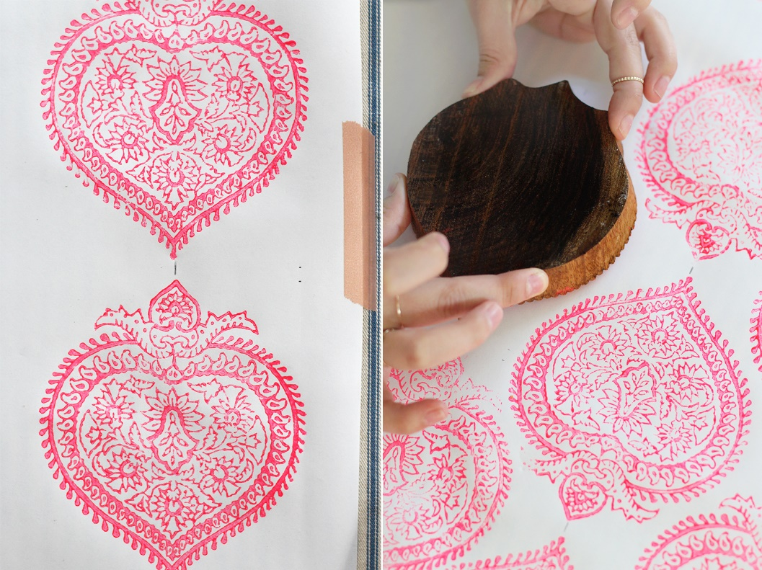
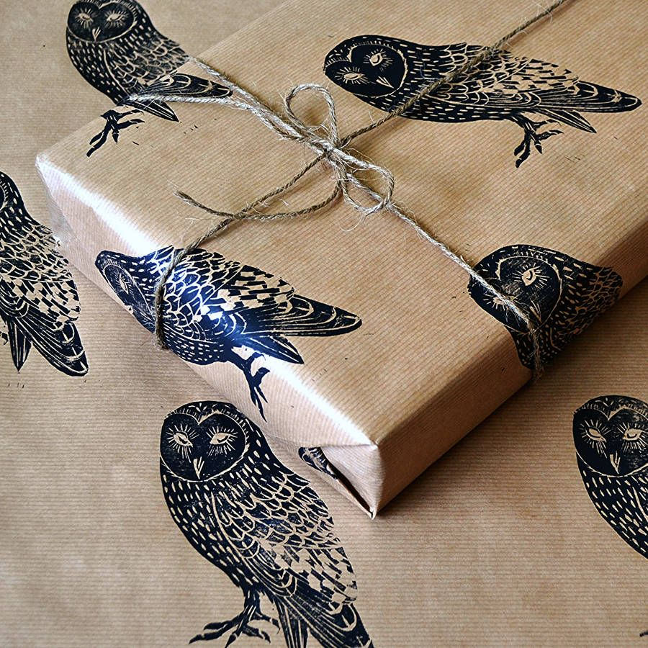
Project: Spray Painted Stencils Adv. Printmaking: Mrs. Riley
Overview:
We are beginning our fourth type of printmaking. Stencils are an impervious material (such as a sheet of paper, plastic, thin wax, or woven fabric) perforated with lettering or a design through which a substance (such as ink or paint) is forced onto a surface to be printed. You will be creating a stencil design of your own that requires layering several stencils to create one image.
Create a stencil to spray paint. Your stencil should have a least 3 layers involved. You may use your layers to show values or to overlap images.
Terms:
- Safety Border: Make sure that your stencil design has at least a 2 inch border around the drawing from the edge of your paper.
- Island: Islands are independent parts inside of a cut-out hole, as you may notice shapes can't float, so that's why they need bridges
- Cut-out hole: This is the place where we place the pigment, it should be stretched and pushed hard against the surface to avoid leaks and blurs. We will tape the stencil down and press in the middle to secure it.
- Bridges: These are the ligatures that make the island possible to exist on the cut-out hole. For example: A bridge has been
Conntected here
and here so Mickey’s face
dosen’t
become a cut out hole.

Requirements:
- At least 3 layers of stencils to be used (3 different colors or shades).
- Cuts are correct so that the image is intact. Refer to cut-out holes, bridges, and islands.
- Layers are lined up correctly to create a clear and straight image.
- Good composition
- At least 2 good and clean prints (good craftsmanship, no smudges, drips, leaks, fingerprints, etc.
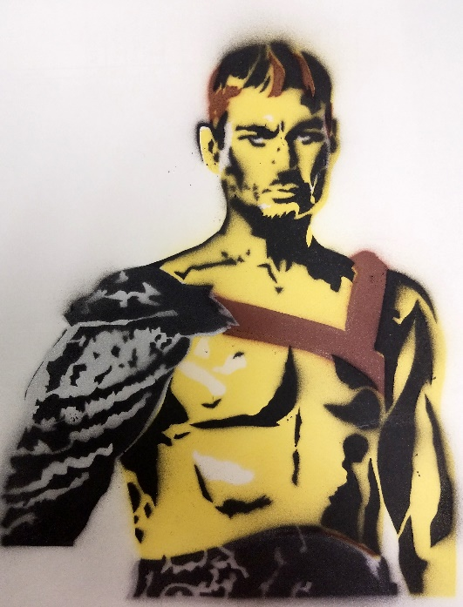
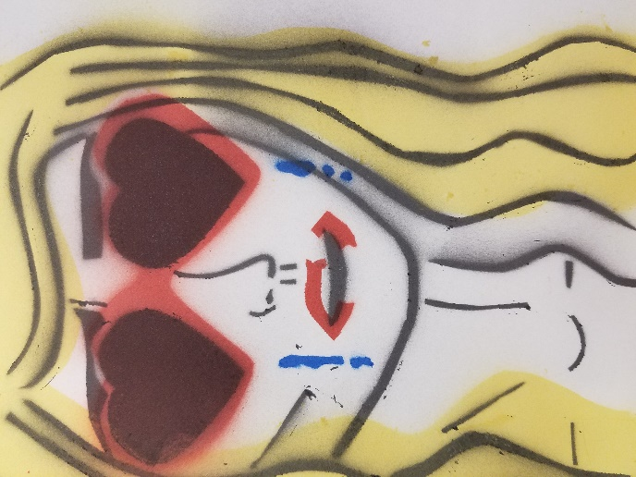
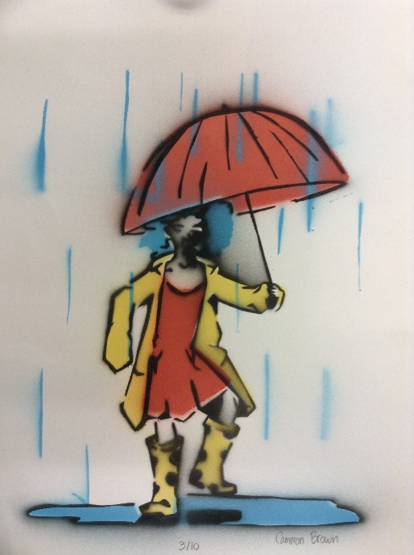
Project: Dry point Etching with Colored Collographs Mrs. Riley: Adv. Printmaking 2
Overview: Subtractive collographs and drypoint etchings are not new to you at this point. We are going to challenge ourselves by combining the two together into one art piece. We are also going to for the first time, control color variation within the collograph print.

Directions: Complete a subtractive collograph plate as normal. When it comes time to print, you will paint on different colors in specific areas of your plate. You may mix colors together but remember that you only need small amounts of ink. Do not waste ink! The wiping here will be very meticulous as you will need to make sure that you do not run the colors together. Print several of these as one or two will remain this way.
The others you will layer on a drypoint print to add mark making and details to your collograph. Hatching and crosshatching will be huge here. Line up your plate over your collograph and draw the image on the top of the plate with a micron pen. Flip the plate over and do your line work on the bottom where it will sit on top of the collograph. Make your marks scratched enough to show white. Clear marks will not print. When finished, ink as normal making sure to completely wipe the ink from the surface.
Soak your collograph print in water like you would regular paper. Pat it dry so paper is damp but does not have standing water on it. Flip your plate over and carefully line it up on your collograph print so that both images line up and become one. Once aligned, sandwich the paper and plate together with your hands and carefully flip them over to lay it on the press so that the paper is up and the plate is on the bottom. Roll through the press. Make sure it is adjusted to allow space for the dry point plate and the matboard. DO NOT HAVE THE PRESS TOO TIGHT.
Refrence: Watch this video:
https://www.youtube.com/watch?v=ViihrZhdxCs
Belinda Del Pesco: How to mix collograph and drypoint printmaking for full color prints- whale and mermaid
Requirments:
- 20pts. Good composition- rule of thirds, design fills the plate so that things go off the page, etc.
- 20pts. Successful collograph print- Color is wiped correctly so that the image isn’t cloudy with smears in the ink.
- 20pts. Successful dry point layered print- cuts are deep and roughed up enough to be visible.
- 20pts. Mark making is used to show a full range of value on the dry point plate
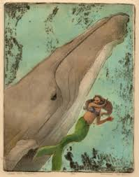
- 20pts. Good Craftsmanship- Two plates are lined up well, no smudging or extra ink on the edges of the paper.
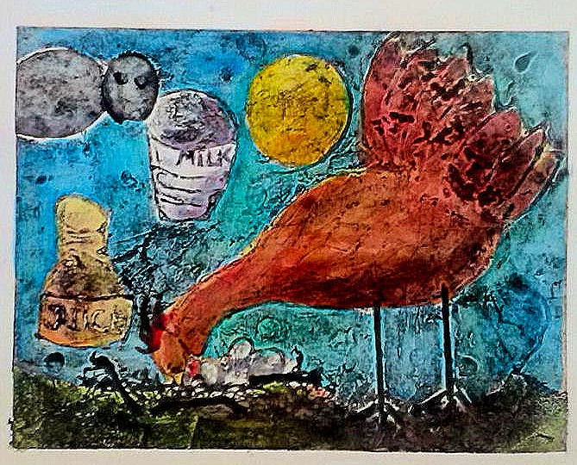

Project: Photo Transfers on Wood with Mixed Media Mrs. Riley: Adv. Printmaking 2
Overview: This is a super simple type of printmaking that makes a beautiful product. This borderlines on a craft. You can transfer images multiple ways. We will be using a technique with mod podge and adding mixed media. Once you learn this technique, try it on your own to make clocks, holiday ornaments, etc.
Directions: On a piece of wood, glue down a photograph, picture up, using mod podge. Allow it to dry overnight. With a damp sponge, scrub the paper from the wood. The paper should come completely off leaving the image behind. Let dry and check to see that all of the paper got scrubbed off. If not, scrub again. Once finished work back into your transfer to create mixed media piece. You may draw or paint back into your work to enhance your photograph. If this were a craft class your work could stop here. Because it is an art class, use this opportunity to turn your photograph in to a fine art piece with what you add to it. It should not just be a photograph when you are finished.
Refrences:
http://www.agirlandagluegun.com/2016/12/transfer-photos-wood-4-different-ways.html
How to transfer photos onto wood- 4 different ways
Requirements:
- 20pts. Clean photo transfer on wood. No bubbles in paper when using mod podge, paper has been cleanly scrubbed away.
- 20pts. Good Composition- photo fills up the wood, rule of thirds is used, image touches or goes off the edge in at least 3 places.
- 20pts. Medium is added to the photograph to transform it from a photo to a fine art piece.
- 20pts. Artwork is orginal- your own photograph and design is used to make your artwork.
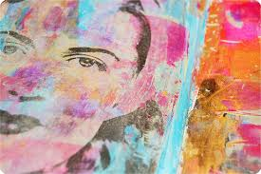
- 20pts. Participate daily and a completed project is turned in.
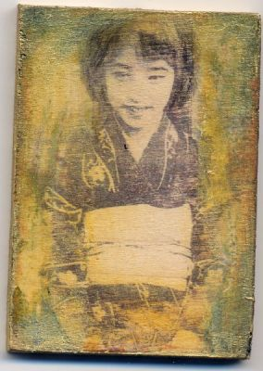
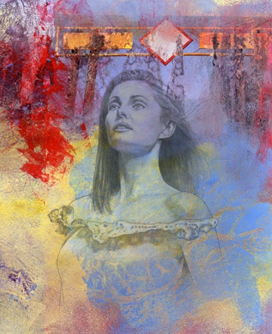

Project: Lithography Mrs. Riley: Adv. Printmaking 2
Overview: Lithography is a play on the fact that oil and water do not mix. This type of printmaking is very science-y in how it works. True Lithography involves drawing with oil on limestone and printing from there. We will be doing a variation of Lithography involving household materials.
Directions: Wrap a piece of aluminum foil around a scrap piece of matboard and smooth it out so that there are no wrinkles. Do a drawing on your foil using lithography pencils. Keep a good composition and mark making in mind. Take your foil off the board and soak it in a tub filled with white vinegar. Set a timer on your phone for 7 minutes. After time has ended, take the foil to the sink and hold it over while spray it with water with a spray bottle. Spray both sides to wash off the vinegar. Lay your drawing flat on a piece of watercolor paper and pour a little vegetable oil on it. Use a paper towel to wipe the oil all over the foil. Wipe off the excess. You will also flatten out the foil while wiping. To ink: use two different sponges (one clean, one dirty). Use the clean sponge to wet your foil. Using litho ink and a brayer, brayer on ink over your foil. It should only stink to the drawing. With your dirty sponge, buff off the ink from the surface of the foil so that it is only on your drawing. Set the press really tight and put the foil and the watercolor paper (just leave them together) on the press. Layer your paper on top and print.
Refrences:
https://www.pinterest.com/pin/243264817354733568/ or https://www.youtube.com/watch?v=tXaimUkCVU0&feature=share
How to Etch with White Vinegar (Kitchen Lithography Variation)
Requirements:
- 20pts. Drawing has a good composition- rule of thirds, fills the space, goes off the page, etc.
- 20pts. Drawing show a range of values with markmaking.
- 20pts. Good craftsmanship with printing, clean edges, no finger smudges, etc.
- 20pts. 2 good successful prints- clear lines, evenly inked.
- 20pts. Good daily participation and a completed project is turned in on time.
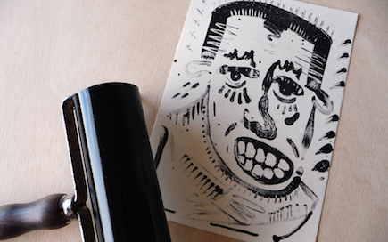
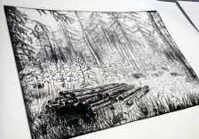

Project: Screen Printing Adv. Printmaking: Mrs. Riley
Overview:
Screen printing is an art form in which you force ink onto (a surface) through a prepared screen of fine material so as to create a picture or pattern. This can be done by carving out a stencil or exposing a screen covered in emulsion to light much like the way a photograph is produced. You will be creating a stencil design for your screen printing project, much like the one you made for spray painting. We will layer images together to create your look. Keep in mind that even though you are creating multiple layers, you can also blend colors together within a layer to create a rainbow effect if desired.
Create 3 stencils that work together in the way that you like. You may have 3 layers to create one image (showing 3 different colors in one image or 3 different values) or you can have 3 different designs that you layer together to create one big artwork. This is up to you. You also have the option of bringing in fabric to make your own wearable artwork.
Note: In our last stencil, it was important to bridge gaps between floating items. You do not have to worry about doing so in your design for this one. Your floating objects will stick to the screen in the correct place.
Requirements:
- Design that looks good repeated to create a pattern.
- Screen is masked correctly so that there is no gaps of ink where there shouldn’t be.
- Design is lined up so that pattern is seamless.
- Pattern is large- at least 24x30. Print on fabric and paper.
- Clean up is imperative. You must clean up after yourself! Wash your screen and tools, put them back where they go and wash your workspace.
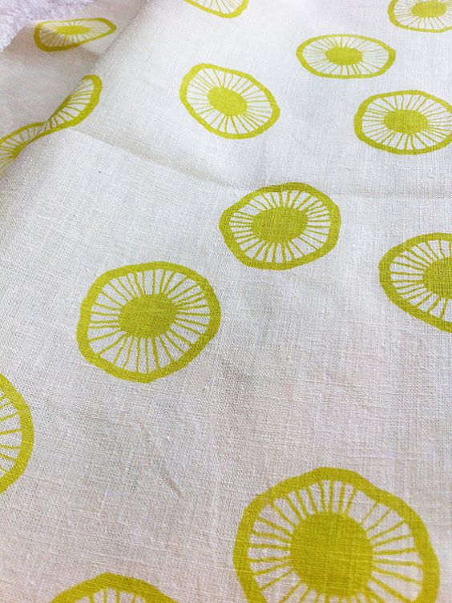

Project: Portrait/The Memory Project Mrs. Riley: Adv. Printmaking
Overview:
This project is designated for the Memory Project, an organization that helps underprivileged kids around the world. We spend $15 and receive a portrait of one of their students to create and send back to them. In return, we receive a video of them getting their portraits. It’s an amazing experience that I hope you will participate in. If you choose not to participate, you will be doing a portrait of someone you know.
You will get to choose the type of printmaking that you would like to use for this project. The goal is to get as close of a representation to the photo as possible so choose a method you feel most comfortable with. Let me know the process you choose so that I can prep your materials. We will use a grid drawing or the light table to transfer your image.
VA:Re.7.1.IIa: Recognize and describe personal aesthetic and empathetic responses to the natural world and constructed environments.

Objectives and Rubric:
___/30 Artwork is representational to the person you are portraying.
___/20 You have correctly prepped the plate in which you are using.
___/20 Correct values have been used and match the photograph.
___/20 Two successful prints (no smudging, clean edges, solid image)
___/10 Daily participation during studio and clean up. Student has a completed project.

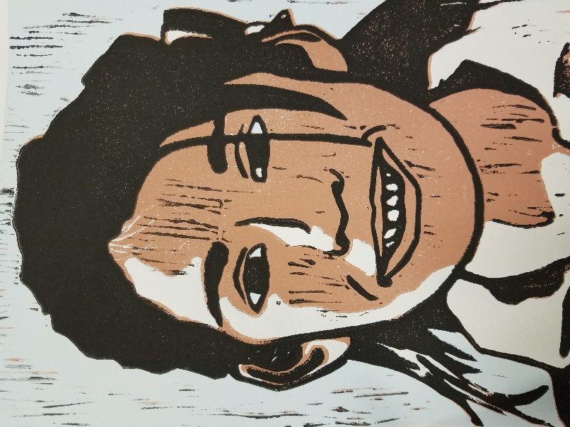
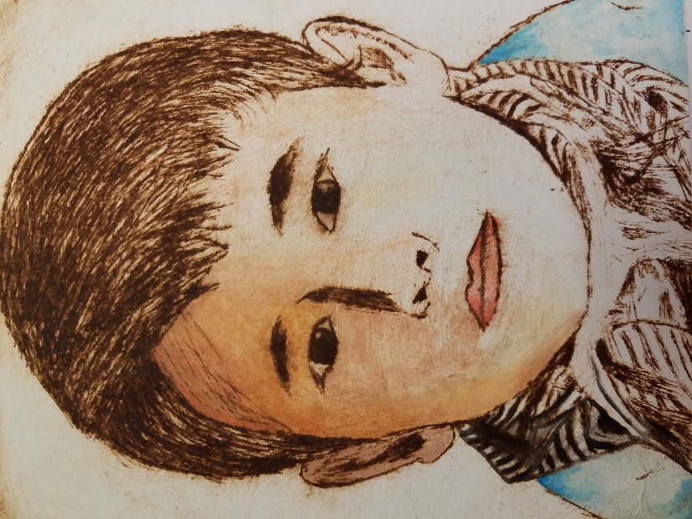

Make your own print from start to finish (Paper included)-Final Mrs. Riley: Adv. Printmaking 2

Overview:
Now that you are ending your 2nd year of printmaking courses, you are a pro! Show me what you know by creating a print from start to finish on your own, including the paper.

Reference:
https://www.instructables.com/id/How-to-Make-Handmade-Paper/

Materials:
-5 sheets of construction paper. (you can use any type of paper you have at home that does NOT have a shiny coat or wax on it)
-2 sheets of white paper (optional)
-About 3 gallons of warm water. (you won't necessarily use the entire amount)
-A big enough container to hold that much water and fit the mold.
-A paper mold
-10 felt sheets
-Sponge
-Blender

Directions:
1. Heat 3 gallons of water on the stove or microwave until warm but not hot. It should be cool enough for you to touch.
2. Break the five sheets of paper into small squares. Add half of the paper scraps to the blender with 5 cups of water. Let it stand for one or two minutes before processing. Mix in the blender for 1 minute. You shouldn't see big chunks of paper. Deposit the mix in the container.
3. Do the same with the remaining sheets.
4. If you want, you can mix the 2 sheets of white paper. The end result will have a smoother color.
5. Mix everything together in the container.
6. Add another 4 cups of warm water and mix well. You should have a fine pulp of paper.
7. Get your mold and start submerging it in the pulp. The pulp should form a fine film over the screen sheet. In the pictures you can see that my pulp was too thick, so I added 5 additional cups of warm water. Then my pulp was ready. You can keep adding a little more water if you think it's still too thick. The consistency should be soupy. You won't necessarily use the entire 3 gallons of water.
8. Submerge the mold completely in the pulp, then pull the mold up. (with this type of mold that i made you don't need a decal because the extra pulp on the sides will slide off)
9. Let the excess water strain.
10. The paper pul must have settled now in the mold. Immediately after straining the excess water, put your mold (with the pulp facing down) on top of the felt sheet.
11. Like you see in the picture, press with the sponge to remove any remaining excess water. Do that until no more water comes out.
12. Now start puling the mold from the felt sheet slowly. It'll come off easily if you got all the excess water out completely. Your paper should peel off completely from the screen sheet.
13. Once it is on the felt sheet let it dry. It takes about 2 says to dry completely. If you want to speed things up, you can put in the microwave for one minute. Then let it dry for 12-15 hours.
14. Repeat this process for every sheet of paper that you want to make. From this recipe you should get 8-10 sheets. (8 x 6 inches each)
15. Now that your paper is dry. Peel the paper from the felt sheet very carefully. When it dry it comes off very easily with no pulling.
16. Now you can write on it, even print on it with you computer printer.
17. FINAL TIP: If you really want to have a fine and delicate look, while the paper is still wet, put another piece of felt on top and iron it. DO NOT iron directly into the paper, that's what the second piece of felt is for. The paper must between the two felt sheets. What this does, is that the final product has a smoother finish, instead of the rough marks of the screen.

Choose a type or relief printmaking that you would like to do (lino, additive collograph, woodcut, gelli prinitng) and print on your made paper.

Requirements:
- 25pts. Good craftsmanship with handmade paper- smooth, stays together well, not lumpy.
- 25pts. Successful prints (2)- clean edges, solid ink, no smudges.
- 25pts. Good composition with design- rule of thirds is used, design fills plate, etc.
- 25pts. Full range of value is used with mark making.

